Reykjavík University 1.03.2015

Test and measurements in Psychology Assingment 2

Exam number: 31984

6,4 or 16/25

**Question 1 - Item Response Functions and Person Estimates**

1. **Which item was the easiest item and which item was the hardest? (2 points)**

Item 10 was the hardest, it was: 0,53  
Item 5 was the easiest, it was: -1,63

1. **Provide a 95% confidence interval for the easiest item and interpret it. (2 points)**

**-2**

**(c) Provide a plot that contains both the easiest and the hardest item. (1 point)**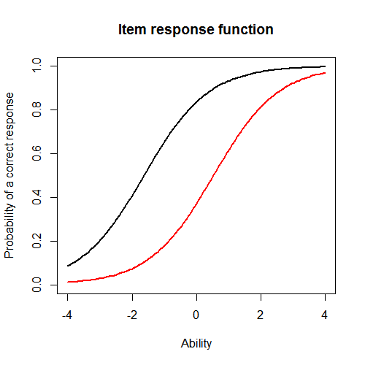

**(d) What would we expect the probability of a correct response would be for someone who had an**

**ability score of 0 for these two items? (2 points)**

For item 5 the probability would be 0.8. For item 10 the probability would be 0.4.

**(e) What was the score of the person who did the best on the test? What was the score of the**

**person who did the worst on the test? (2 points)**

The person who did best on the test scored 3.999921. The person who did worst on the test scored 3.999947

**(f) Provide a 95% confidence interval for the estimated ability for the student who did the best on**

**the test and interpret it. (2 points)**

**-2**

**Question 2 - Information**

For this question, you will choose three items to investigate.

**(a) Please state the three items you selected. (1 point)**

Items 2, 4 and 6.

**(b) Provide a plot that contains these three items’ information functions. (1 point)**

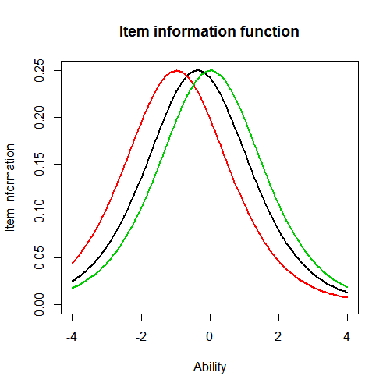

**(c) What is the same about these items’ information functions? What is different? Hint: This can be a very short answer. (2 point)**The majority of the information on all items are located different. The item information is the same for all items. What is different -1

**(d) Provide a plot of the test information function. (1 point)**

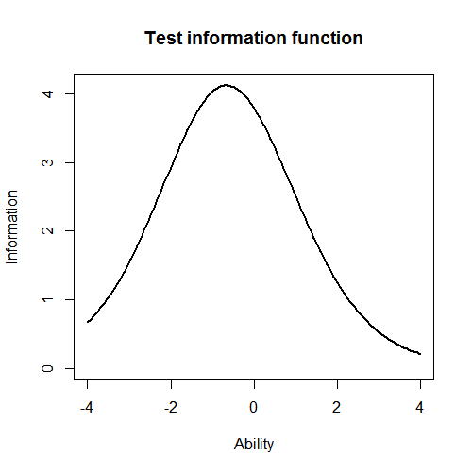

**(e) Where is the majority of the information for this test located? (1 point)**

At -1.

**Finally, you will need to run a 2-PL.**

**Question 3 - Comparing the 2-PL**

**(a) Which item had the highest discrimation? Which one had the lowest discrimination? (2 point)**

Item 8 had the highest discrimination, it was: 2.2881772. Item 12 had the lowest discrimination, it was: 0.3329130.

**(b) Are the items that were the easiest and hardest in the Rasch model, also the easiest and hardest in the 2-PL? (1 point)**

The hardest item was the same in Rasch model and the 2-PL. The easiest item was not the same in 2-PL as in the Rasch model.

**(c) What is the correlation between the ability estimates on the Rasch model and the 2-PL? If your interest was solely on estimating person abilities, do you think you would draw the same conclusions from both models? Why? (2 point)**

-2

**(d) Provide a plot of the item information function for the three items you selected in Question 2 but this time for the 2-PL model. (1 point)**

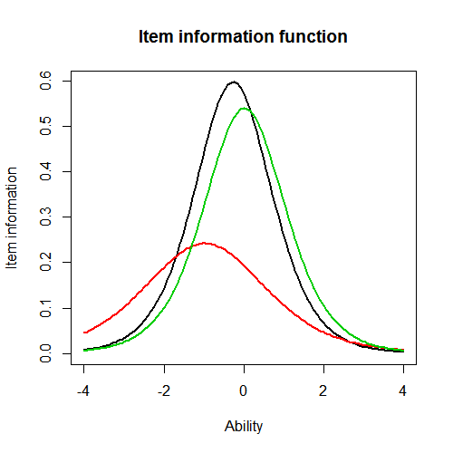

**(e) For the 2-PL model, how do the item information functions for these items differ? How do the 2-PL item information functions from these items differ from their Rasch item information functions? (2 point)**Item 2 is much lower than items 4 and 6. On the Rasch model the items were much more like each other.

You need to discuss more. What is the same about the items and different? Please see the answer key -2